# Process Scoping, Stakeholder and Risk appetite analysis [10]

**Stakeholders for the process**

|  |  |  |  |  |
| --- | --- | --- | --- | --- |
| Stakeholder Category | Role | Level of interest | Level of importance | Level of influence |
| Analyze CEO | Responsible and manages all sales process by tracking sales volumes. | High | High | High |
| Analyze COO | Responsible to all activities that involves day to day deliveries. | High | High | High |
| Analyze Executive Assistance | Handles procurement processes and activities. | High | High | High |
| SA Government | Responsible in checking Policies Compliance. | Low | Medium | High |
| Sales Employees | Follow Sales business process to manage sales. | High | Medium | Medium |
| Delivery Team | Delivers service requested to clients | Medium | Low | Medium |
| Clients | Request services from Analyze. | Medium | High | Low |
| Suppliers | Provide services requested by Analyze. | Medium | High | Low |

**Stakeholders for the project**

|  |  |  |  |  |
| --- | --- | --- | --- | --- |
| Stakeholder Category | Role | Level of interest | Level of importance | Level of influence |
| UCT team | Understand Analyze current problems and suggest solution by Re-design a BP that meets Analyze needs. | High | High | High |
| Mentor | Guide and monitors UCT team’s project progress | Medium | High | Medium |
| Project Sponsor | Provides resource and support throughout the project’s existence. | High | High | High |
| EY members | Input ideas and suggestion on how to go along understanding the Analyze business problems. | Medium | Low | Medium |

# Risk appetite

*Risk for the current process*

|  |  |  |  |
| --- | --- | --- | --- |
| Risk Category | Risk Description | Likelihood | Controls |
| Cyber-Security Risk | Third party companies can get attacks | High | Make sure that third parties invest in fraud detection tools and software, since they have access to client data. |
| Compliance Risk | SA Governance finding out that Analyze has no Policies implement (Policies that complies with POPIA) | Medium | Define the processes needed to adhere to their policies. |
| Data Risk | Employees email accounts hacked/ cell phones stolen | High | Have two factor authentication for emails accounts and develop email management system to remind employees to delete emails. |

*Risk for the future process*

|  |  |  |  |
| --- | --- | --- | --- |
| Risk Category | Risk Description | Likelihood | Controls |
| Cyber-Security Risk | Due to the nature of the business every activity is done online and even the additional system can get cyber-attacks. | High | Invest in fraud detection tools and software security. |
| Operational Risk | Human errors caused when using additional system to the current business | Medium | Make time for training employees to minimize internal mistakes that can occur when using additional systems. |
| Operational Risk | Poor change of management of business process. | High | Prepare employees with proper resources, onboarding, and guidance to help them adapt to changes and additional software systems. |
| Technology Integration Risk | The new BP and additional system being unable to maintain data integrity resulting in data architecture and business outcomes affected negatively | High | During implementation the project team must continually verify data integrity as it moves to new system. |

# Scooping Diagram

*- Include a scoping diagram. In the centre of your scoping diagram include your high-level diagram of the existing process with Management activities. Indicate process problems with all 6 categories.*

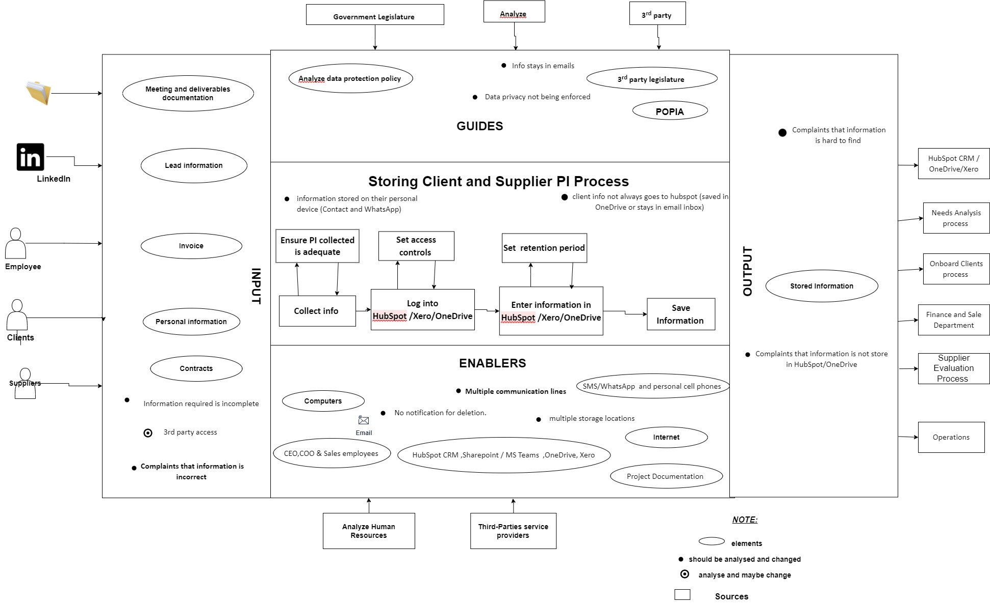

# Introduction [2.5]

The project**:** Creating, storing, archiving, and destroying client and supplier data.

Business process: is for managing and deleting client and suppliers.

People we interviewed*:* T’Nielle Brooks (Executive Assistance), Amandla Bulder (Chief Operating Officer), Jeremy Chetwin (Chief Executive Officer).

Document we got from Analyze company: *Analyze data private policy, Analyze Project Brief for POPI process design UCT and Analyze Retention and Destruction Policy.*

*Project report is structured(Table of content ):* Process Scoping, Stakeholder and Risk appetite analysis, Business Case, Business Process Analysis, Suggested Process Redesign, Process Reporting, and conclusion.